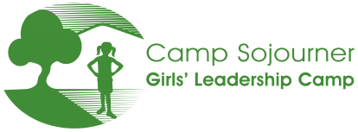
Returning Junior Counselor Application, Summer 2024

Name: _______________________________________ Age you will be at camp: _______
School you attend: ______________________________ Grade Fall 2024: _______

- Why are you interested in coming back to Camp Sojourner as a Junior Counselor in 2024?

2. Based on your role as a Junior Counselor last summer, how would you rate yourself in the following areas? (1 is low, 5 is high)

Working as part of a group 1 2 3 4 5
Following through on things I commit to 1 2 3 4 5
Being places on time when expected 1 2 3 4 5
Asking questions if I don’t understand something 1 2 3 4 5
Sharing my ideas 1 2 3 4 5
Supporting campers to try new things 1 2 3 4 5
Interacting with campers in a mature, positive way 1 2 3 4 5
Planning ahead for needs of campers 1 2 3 4 5
Planning ahead for program activities and supplies 1 2 3 4 5
Acting as a positive role model to campers 1 2 3 4 5
Attentive to safety all around camp 1 2 3 4 5
Helping create emotionally safe space for campers 1 2 3 4 5
Asking for help when needed 1 2 3 4 5

- What were some highlights for you being a Junior Counselor last summer? (What did you enjoy? What have you learned from? How did you contribute?)

- How do you think the Junior Counselors as a group benefitted the camp community last summer?

5. What changes would you recommend for the Junior Counselor Summer Program this year?

6. How could you improve or grow in your role as a Junior Counselor this year? Please name at least two personal goals for your time at camp this year.

7. Any other thoughts?

______________________________________________________________________ _____________
Signature of Camp Sojourner Junior Counselor Date

Thank you!

Applications are due by March 15.
You can email your application to
alisha@girlsleadershipcamp.org
or upload it into your Ultracamp account.

